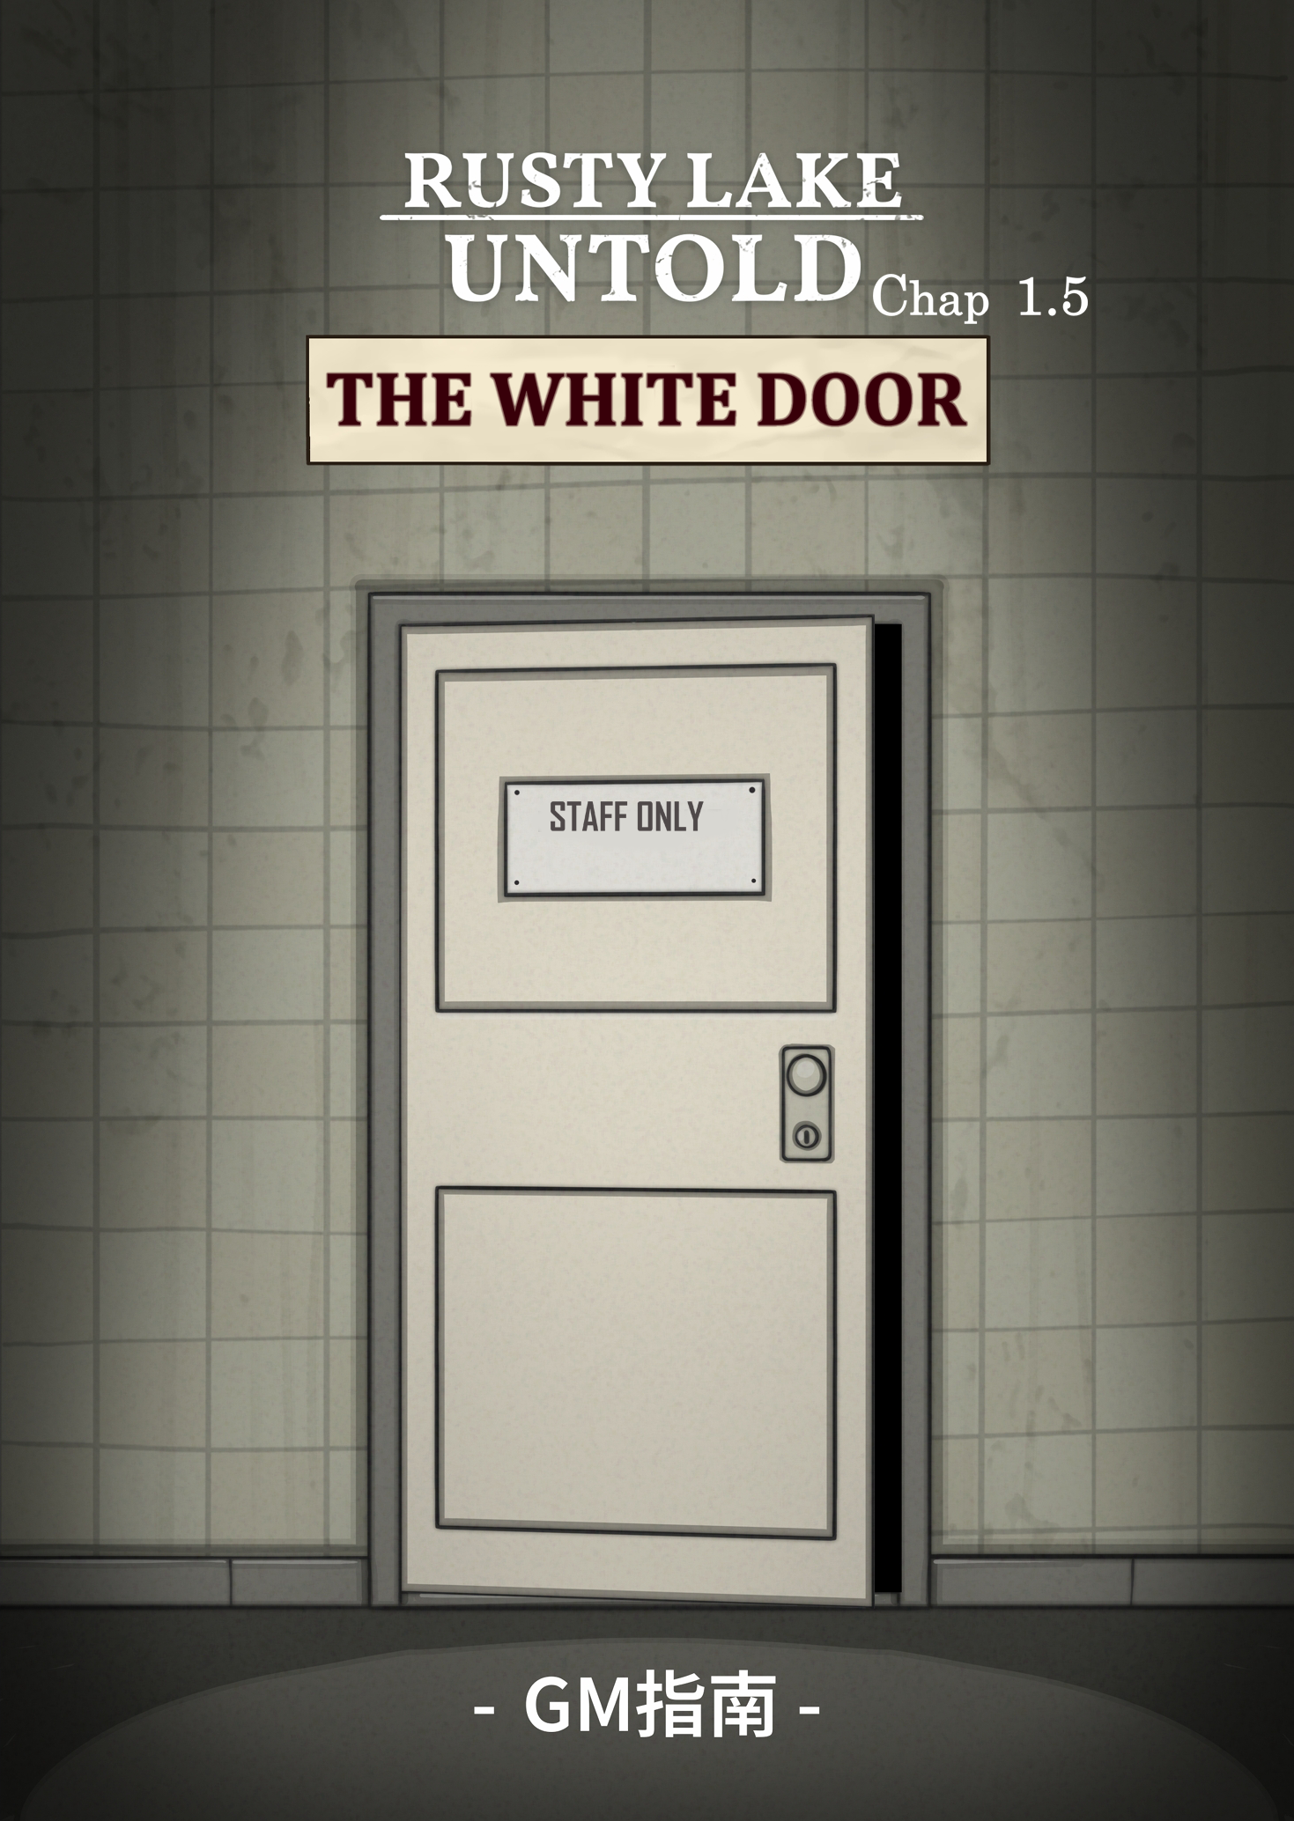



straynut321 (Translator)

*极品电伊特 (J.P.D.Y.T)*

*贝尔伊万*

*纪录片*

*蝶*

*黑羽夜风*

*And a number of dedicated play-testers who helped during the early stages*

*We would like to thank all the members of the development team. We also extend our heartfelt gratitude to the official Rusty Lake studio.*

**Development team**

**Rusty Lake Untold** is an escape room-style tabletop game that captures the signature eerie atmosphere of the Rusty Lake series, while offering a brand-new experience through its unique board game format.

You can play this game anytime in real life. We recommend printing out the game guide and cards, or using an electronic device (like a laptop or tablet) to access the digital version for easy reference during gameplay.

If those options aren’t available, you can also play the game online. If you don’t have friends to play with, feel free to join our fan-made tabletop game group chat (QQ: 148871993) or official discord server to find a Game Master and fellow players.

*Any game related issue can be reported to J.P.D.Y.T via discord.*

The core rules of the game are the same as *Rusty Lake Untold*. Players are free to interact with objects in the room, including but not limited to:

• Examining certain items

• Picking up certain items

• Taking apart or combining certain items

After players describe their actions, the Game Master (GM) should respond appropriately to let them know the outcome of their actions.

*This fan-made game is more challenging than the original Untold game. Therefore, players are encouraged to use the Internet in addition to pen and paper to assist them during gameplay.*

**Gameplay Notes**

***This game is a fan-made tabletop game based on the Rusty Lake Untold series from Rusty Lake.***

***Please support the official Rusty Lake titles.***

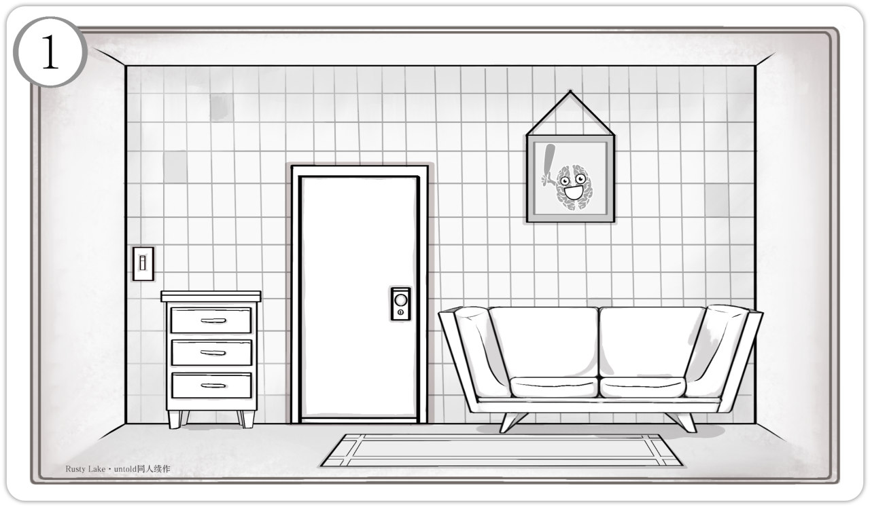

*“You jolt upright from the couch, the ringing in your ears lingering like the static of an old television. The room before you is familiar, yet shrouded in darkness, it now feels strange and unsettling. You reach for the light switch—nothing. You turn the doorknob—it won’t budge. You’re locked inside. A sense of dread begins to rise within you…”*

***“The Past is never dead, it is not even the past.”***

**Staff Room**

**1. Sofa**

This is the place where you awoke from your slumber.

Four cushions of various shapes rest on the couch. Players may choose to inspect them and will find that the backs of the cushions are labelled: “1”, “4”, “9”, and “16”.

**2. Cabinet**

A small cabinet stands against the wall, containing three drawers:

• Checking the top drawer yields a bottle of cleaning solution.

• In the middle drawer, players will find a flashlight. Upon further inspection, they’ll notice that the back cover of the flashlight can be removed, revealing the battery compartment inside.

• The bottom drawer contains a locked box with a three-digit code. The correct code is 343—only by entering the correct number can players open the box and retrieve the key inside.

**3. Carpet**

Players can move the carpet to reveal a pattern hidden beneath it. However, the room is too dark to see clearly—only with the help of the flashlight can the pattern be fully made out.

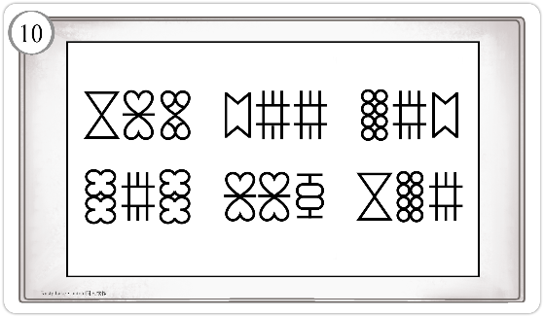

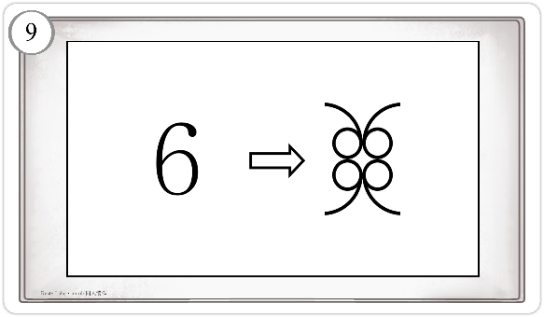

The pattern consists of mirrored segments of Arabic numerals, divided into four parts. To solve the puzzle, players must recognize that the cushion numbers follow a pattern of perfect squares—then identify the only number in the pattern that is not a perfect square: 343.

Hint: The usage of a calculator is advised

**4. Door**

The door is locked. It’s solid and sturdy—trying to force it open would only result in injury. The only way through is with the correct key. When players inspect the door, they’ll notice a slip of paper wedged in the crack, as shown in the illustration below:

The note offers a clue to the strange symbols beneath the carpet: after distorting the Arabic numerals, apply both horizontal and vertical flips to interpret them correctly.

**5. Light Switch**

The light switch is currently non-functional. Since there is no electrical room in this game, the light switch will remain inoperative throughout.

**6. Photo Frame**

A glass picture frame hangs conspicuously on the wall. Inside it is an image of Mr. Memory, holding a large club.



A map is posted on the hallway wall, and it’s connected to the final puzzle. Players will need to determine the solution based on Mr. Memory’s location in each of the five rooms. A visual hint is provided below.

Players must follow the direction of the arrows and input the numbers corresponding to the suits of the cards—in the order: Clubs, Hearts, Spades, Clubs, Diamonds.

**3. Hallway Graffiti**

When players shine the flashlight along the hallway wall, a message briefly appears:

***“All that you touch, you change.”***

But when they try to take a closer look, the words vanish without a trace.

*With unease in your heart, you step into the long, dimly lit corridor.*

*Guided by the beam of your flashlight, you see that the rooms lining either side appear just as they should. After turning a corner, you reach the end of the hallway—where a pale sheet of paper is pinned to the wall.*

**Corridor**

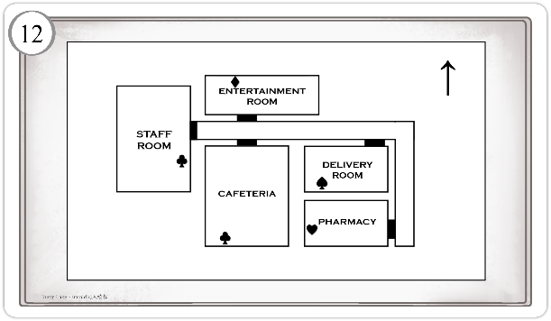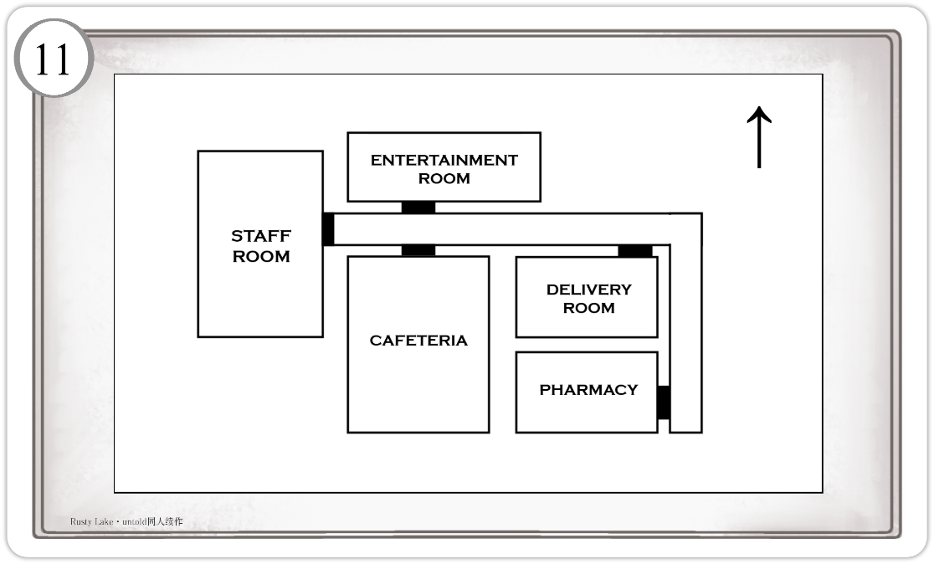

**1. Doors**

There are several doors in the hallway that players can investigate. This guide will follow the default exploration order:

**Cafeteria**

After exiting the staff room and walking down the hallway, the first door on the right leads to the cafeteria. The door is unlocked and can be entered freely.

**Delivery Room**

The door to the delivery room is located at the corner of the hallway. It is also unlocked.

**Entertainment Room**

Directly across from the dining room is entertainment room. This door requires a keycard in the delivery room to open.

**Pharmacy**

At the far end of the hallway, the door on the right leads to the pharmacy. It can only be opened with a key obtained from the entertainment room.

**2. Map**

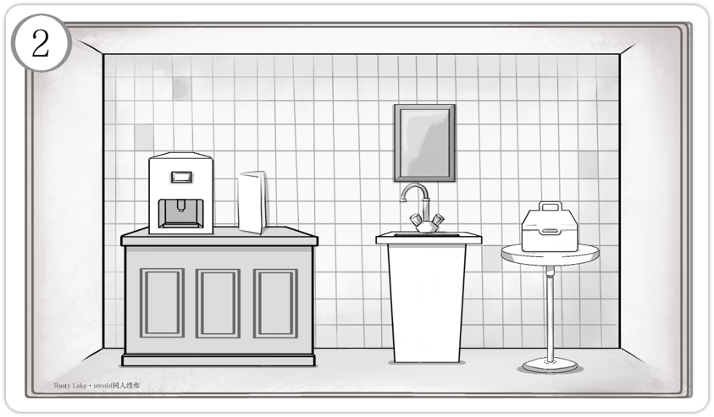

**1. Sink**

The mirror above the sink is covered in grime, fogged up so badly that nothing can be seen. To clean it, players can:

• Use a damp **cloth** soaked with cleaning solution

• Use a damp piece of **rag** soaked with cleaning solution.Once the mirror is clean, players will see an image of Mr. Memory, holding a large club.

The sink’s faucet works normally and provides running water.

**2. Locked Box**

A locked box sits on the round table. The password is a five-letter code: **WRKBY**.

Here, **K** corresponds to black (as in the CMYK color model), and the remaining letters are the initials of **White, Red, Blue,** and **Yellow**.Only by entering the correct code can players open the box and retrieve the screwdriver inside.

**3. Counter**

A menu is placed on the cafeteria counter. Its contents are shown in the images below:

***You step into a place you’ve been countless times before, but the hall, once filled with life, now sits in ghostly silence.****Across from the entrance, on the far wall, you see a self-service drink dispenser sitting on the ordering counter, with the restaurant’s menu standing next to it.*

**Cafeteria**

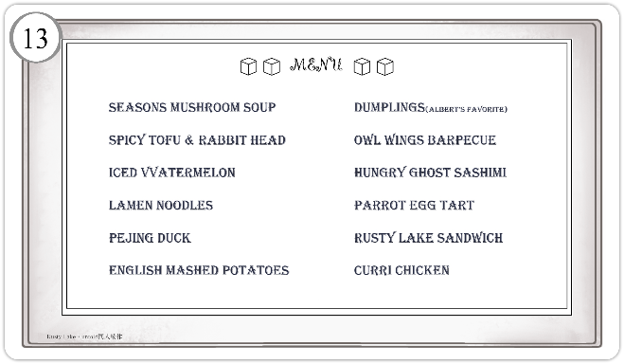



There are five misspelled letters on the menu. If players arrange these letters in the order they appear, they’ll uncover the code to the lockbox.

Also on the counter is a drink dispenser. The machine is missing screws and requires a battery to operate. Once a bill is inserted into the coin slot, the machine powers on and begins producing Bloody Marys endlessly.

***“A thick liquid gushes from the pipe, its consistency like melted wax. Though its color remains unseen, even the dullest of senses can detect the metallic scent—sharp, like rusted iron.”***

If a player smells or tastes the liquid, they’ll notice the flavors of vodka and hot sauce.

Searching behind the counter reveals a battery tucked away inside.

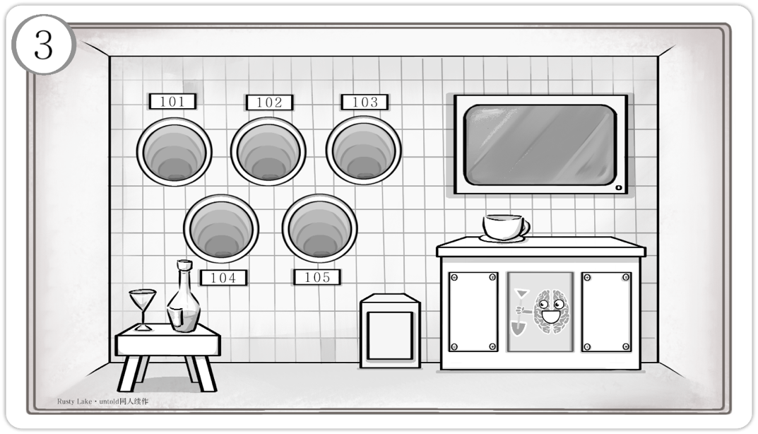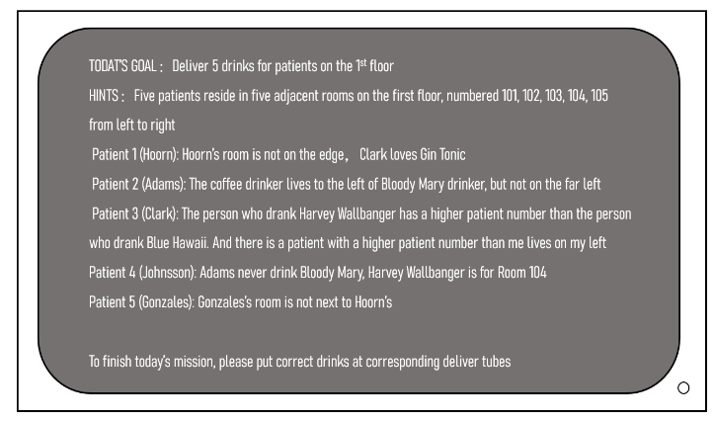

Once powered on, the screen will display the meal delivery requests of five patients.

To fulfill the task, players must follow the on-screen instructions and place the five corresponding drinks into the circular delivery chutes. If the drinks are placed incorrectly, the chutes remain unresponsive. Only when the correct drinks are delivered—Blue Hawaii to Room 101, coffee to 102, Bloody Mary to 103, Harvey Wallbanger to 104, and gin and tonic to 105—will the system activate and automatically unlock the small safe.

*You push open the door, and before you stretch five conveyor belts, extending from the walls into endless darkness.The sight only deepens your unease, a damp, musty scent hangs in the air. From the corners your flashlight cannot reach, faint rustling sounds occasionally emerge.*

**Delivery Room**

**1. Cabinet**

In the lower-right corner stands a cabinet with three square panels.

The left and right panels are sealed with screws—players will need **a screwdriver** to open them.

• Inside the left compartment is a battery slot that can hold **three batteries**, though none are currently installed.

• Inside the right compartment are two cocktails: a **Blue Hawaiian** and a **Harvey Wallbanger**.

The middle panel cannot be opened. A sheet of paper is attached to it, showing an image of Mr. Memory holding a shovel.

On top of the cabinet sits a steaming cup of coffee.

**2. Screen**

The screen is located above the cabinet on the right side. When first discovered, it is powered off. It will only activate after all **three batteries** are inserted into the slot in the left compartment.



***As you set down the final drink, a sharp electronic beep pierces the air. Before you can react, the chute swallows the beverage like a ravenous beast, dragging it into the depths of d***arkness.

**3. Safe**

The small safe is located in the corner of the lower-right cabinet, built into the wall. It contains the keycard for the entertainment room. There is no keypad or place to enter a code—but once the delivery task is completed, the safe opens automatically.

**4. Circular Chutes**

A total of five circular chutes are embedded into the left wall of the delivery room—three above, two below. The insides are shrouded in darkness, and even a flashlight reveals nothing beyond the openings.

Each chute is labeled with a room number from 101 to 105, corresponding to the patients awaiting their drinks. If a player reaches inside to inspect one, they’ll feel a sticky substance—and within it, discover a battery.

**5. Stool**

On the small stool in the lower-left corner sit two glass containers. The one on the left is a glass filled with **gin tonic**. The one on the right is an empty glass bottle containing **a paper bill**. If a player smells or tastes the gin and tonic, they’ll notice the flavor of gin and tonic water.

The empty bottle cannot be broken, and brute force won’t retrieve the bill inside. Only by filling the bottle with water from the cafeteria can the bill be extracted.

Once obtained, **the bill** must be inserted into the **drink dispenser**, which will then produce an endless stream of Bloody Marys. Filling the bottle grants the player **a bottled Bloody Mary**, which is needed for the patient delivery task.

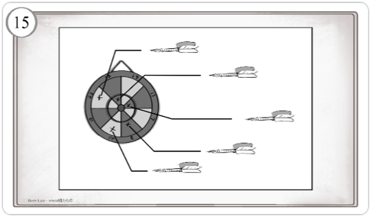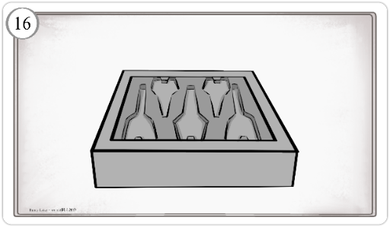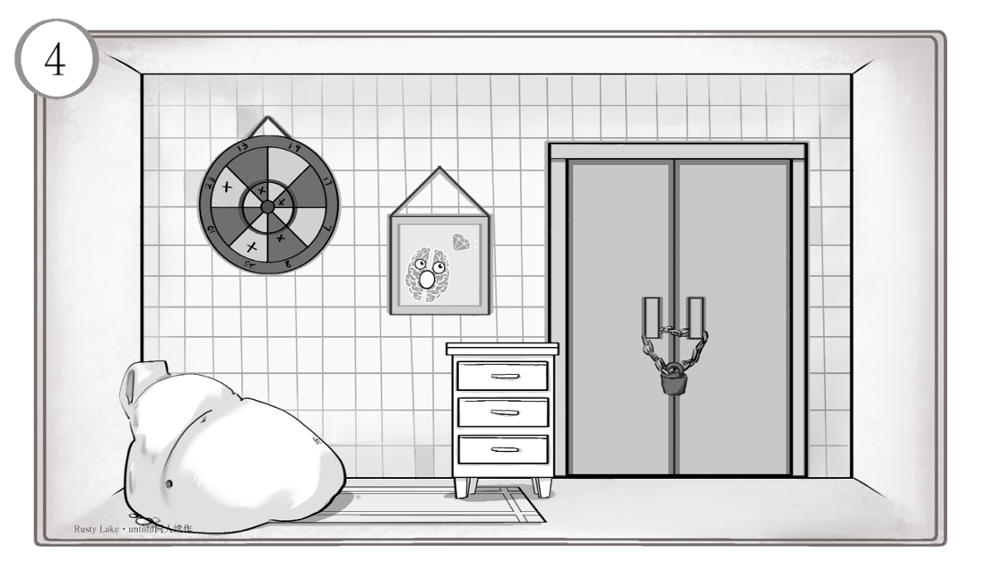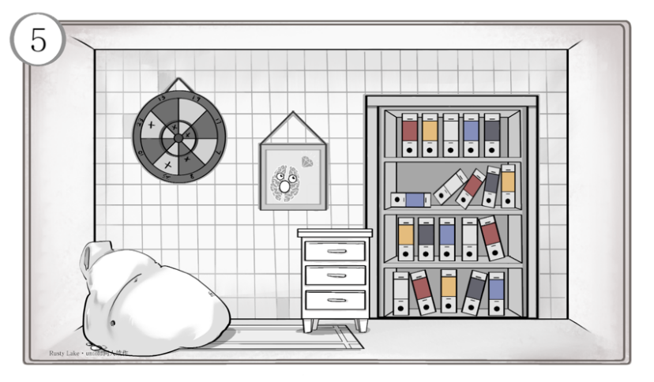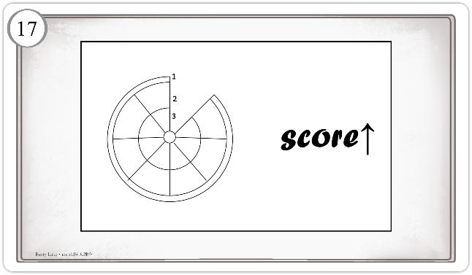

The dartboard is mounted on the left wall of the recreation room. It has an inner and outer ring, each divided into eight segments. Five darts are stuck in different sections of the board, and each one bears a unique inscription. Players can remove the darts to examine the text. The details are shown in the diagram below. (If players are stuck, the GM can suggest they look it up.)

**3. Bean Bag**

The large, plush cushion practically invites you to touch it—but something about it reminds you of certain… unusual patients you’ve dealt with before. An instinctive discomfort rises within you. The dart holes scattered across the sofa suggest this spot might not be entirely safe.

**1. Cabinet**

This cabinet also has three drawers. The top and middle drawers can be opened freely, while the bottom one is locked.

Inside the **top drawer**, players will find a playing card: 5 of Hearts.

The **middle drawer** contains a dart holder embedded in the interior—its lid is missing, but there are five dart-shaped slots. When players insert the darts in the correct order (based on ascending dart scores, calculated using each dart’s score multiplied by the multiplier shown in Figure 17, resulting in the sequence 4-2-1-5-3), the bottom drawer unlocks.

Inside the **bottom drawer** are the Pharmacy key and **the 8 of Spades.**

**2. Dartboard**

*The entertainment room is meant to be a place for relaxation, yet your mind is anything but calm. Everything you’ve experienced so far has left your thoughts in disarray, and the strange paintings on the walls only stir a nameless anger within you. Still, your gaze keeps drifting—almost involuntarily—toward the heavy iron door on the right, as if something important lies hidden behind it… something meaningful for you.*

**Entertainment Room**

• **White, Red, Black, Blue, Yellow** – based on the misspelled letters in the menu, each representing a color.

• **Blue, Black, Red, Yellow, White** – corresponding to the colors of the five drinks.

• **Red, Black, White, Yellow, Blue** – derived from the hexadecimal values on the darts, placed in the dart holder from left to right.

• **Black, Red, Blue, Yellow, White** – based on the icons and colors shown on the medicine containers.

Once all the books are arranged correctly, the bookshelf slowly slides aside, revealing an elevator hidden behind it. The doors creak open. Inside, there is only a single button—pointing down.

After pressing it, a harsh electromagnetic hum fills the space as the doors close. The descent feels endless.

Finally, the elevator stops, and the doors open. Before you is a narrow passageway. At the far end, a dim flame flickers.

You steady your breath, and begin walking toward it…

**5. Photo Frame**

A glass picture frame hangs abruptly on the wall, displaying **Mr. Memory gazing at a diamond**.

Shining a flashlight into one of the holes reveals a piece of paper stuffed inside. Its contents are as follows:

**4. Iron Door**

To the right of the cabinet stands a **heavy iron door**. You try to force it open, but it won’t budge. Still, you can’t shake the feeling that something important lies beyond it.

To unlock the door, players must first obtain the **iron door key** from the pharmacy. As the door opens, a wave of dizziness washes over you, and a strange voice echoes in your mind:

***“Memories are not only the key to the past, but also the future.”***

Your strength suddenly drains away, and your eyes begin to burn. You shut them instinctively. When you open them again, the iron door stands wide open, revealing a bookshelf within. The books, once in black and white, now shimmer in color.

The bookshelf has **four rows**, each with **five books**, in red, yellow, blue, white, and black.

To solve the puzzle, players must arrange the books in the correct order based on a series of clues.

Each **column of books** corresponds to a puzzle from a different room: the **Dining Room, Delivery Room, Pharmacy,** and **Entertainment Room**—in that order.

Players must arrange the rows of books accordingly. Once a row is correctly completed, it can no longer be altered.

The correct color sequences for the four rows, from top to bottom, are:

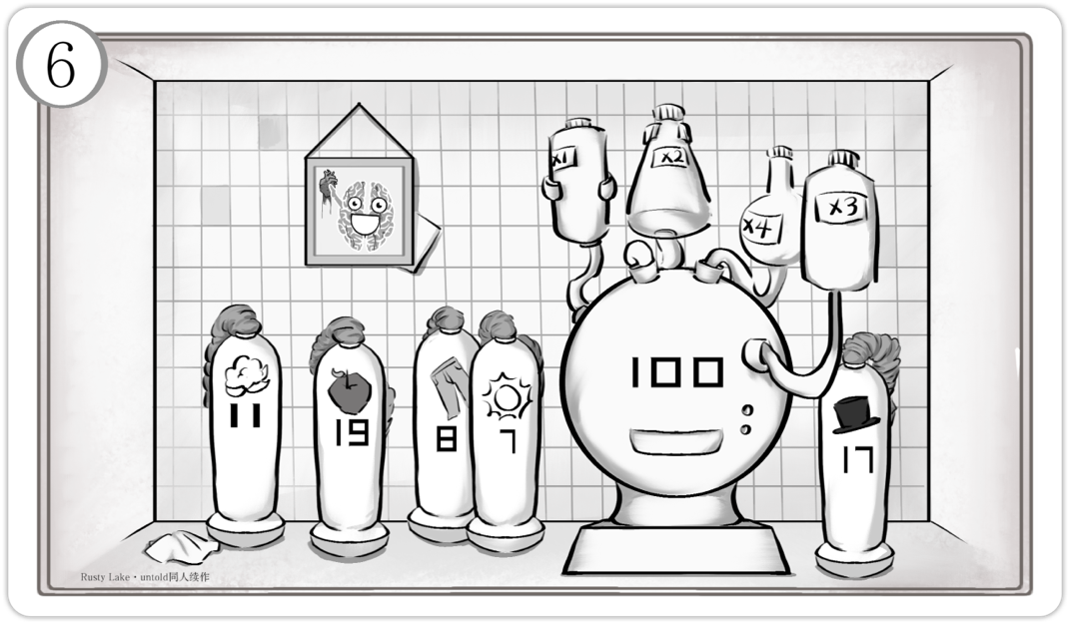

**compartment**, which requires a screwdriver to open.

The device needs **three batteries** to power on, and once inserted, the batteries **cannot be removed**.

The spherical device puzzle is a math challenge: connect four medicine containers so that the **sum of their products** equals **100**. The correct pairings are: 19→x1, 8→x2, 7→x3, and 11→x4. The container marked 17 is unused. Solving the puzzle opens the lower slot, revealing the **entertainment room iron door key**.

**3. Photo Frame**

A glass picture frame hangs abruptly on the wall, depicting Mr. Memory cradling a heart, his body covered in blood.

Tucked into the lower-right corner of the frame is a playing card: the **Ace of Diamonds**.

**1. Medicine Containers**

Scattered across the floor are **five medicine containers**, each marked with a unique symbol and number. Attached to the tops of the containers are **retractable plastic tubes**, long enough for players to connect them to the compartments on top of the large spherical device.

Next to the container on the far left lies a **cloth**, clean on one side and filthy on the other. When players inspect it the first time, they instinctively nudge it aside with their foot—revealing a **playing card: 3 of Clubs** hidden beneath. Only on a second inspection will they actually pick the cloth up.

**2. Spherical Device**

The **large spherical device** is positioned on the right side of the room. The number **100** is prominently displayed on its surface. Below the number is a **small slot**, currently sealed shut. To the right are two **indicator lights**, both unlit.

On top of the device are **four uniquely shaped containers**, each marked with a different label. On the back of the machine is a **battery**

*This is your first time stepping into this hidden corner of a room.*

*Through the crack in the door, you catch glimpses of oddly shaped scientific equipment and vats of foul-smelling liquid. The stench instantly reminds you of countless sleepless nights—of the fluids you once injected into patients, carrying that same nauseating odor.*

**Pharmacy**

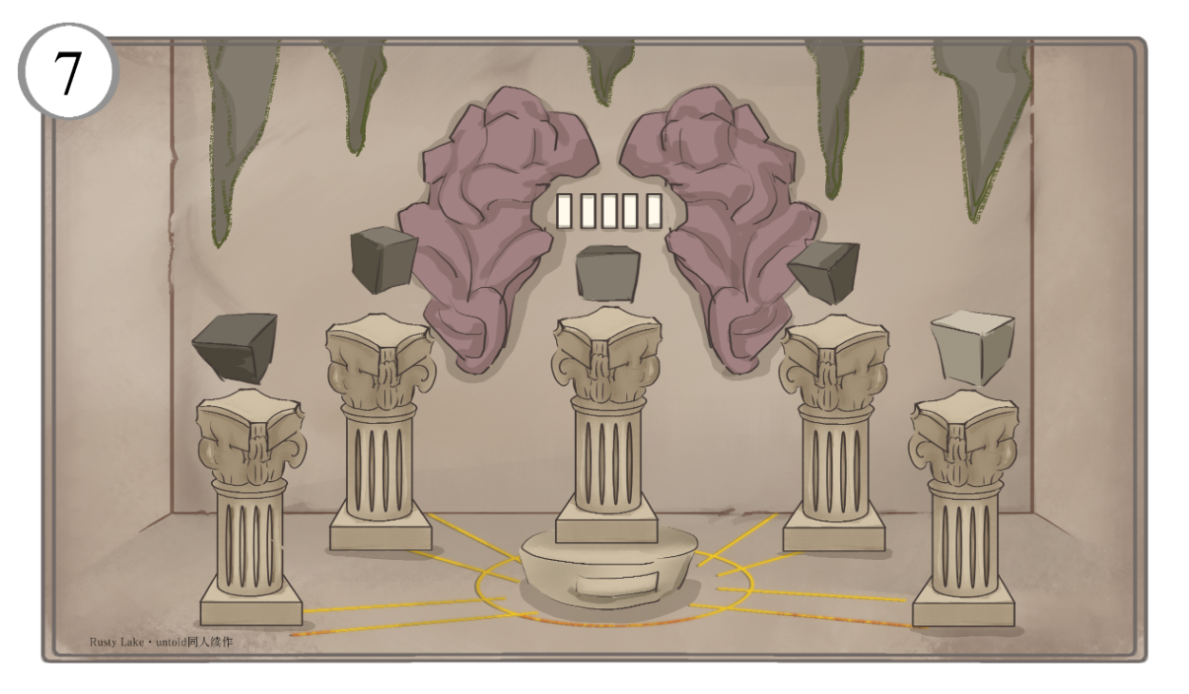

Beneath the central pillar is a cylindrical pedestal with a small compartment. Once the brain mural puzzle is solved, the compartment opens to reveal a **knife**, and the outer cubes turn **black, blue, gold,** and **white**—only the center remains colorless.

A voice echoes in your mind:

**“There will be blood.”**

Now comes the final act. Guided by your own intuition—or the GM’s hint—you place a part of your body (such as your hand or arm) above the colorless cube and use the knife to draw blood, staining it red.

A blinding white light erupts before you. The world melts into a sky full of stars—then, nothing.

**The main game ends here.**

**1.Mural**

Though abstract at first glance, closer inspection reveals the uneven wall carving to be a distorted human brain. It clearly hints that the **five-digit code** is tied to **Mr. Memory**. (In English, suits correspond to items: hearts = heart, diamonds = diamond, clubs = club, spades = shovel—matching the versions of Mr. Memory seen earlier.)

The correct sequence is **Clubs, Hearts, Spades, Clubs, Diamonds**, which translates to **35831**.

Upon entering the code, a deep rumble echoes through the basement. Bits of stone fall from the ceiling, and the central pillar begins to shift.

**2. Pillars**

Five identical Roman pillars are arranged in the stone chamber—one at the center, four surrounding it. Each supports a floating cube, all the same in shape but differing in shade.

*You’ve finally reached the end of the underground passage. You know—this is where you were meant to go. Faded pink carvings draw your gaze along the ochre stone walls, and at the center of the chamber, an ancient, ornate Roman pillar stands in silent grandeur. Atop it, five floating cubes—each varying in shade—hover quietly. You realize: this is the final trial that stands before you.*

**Basement**

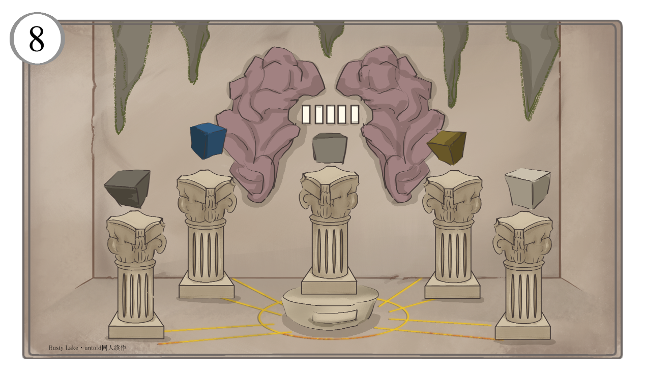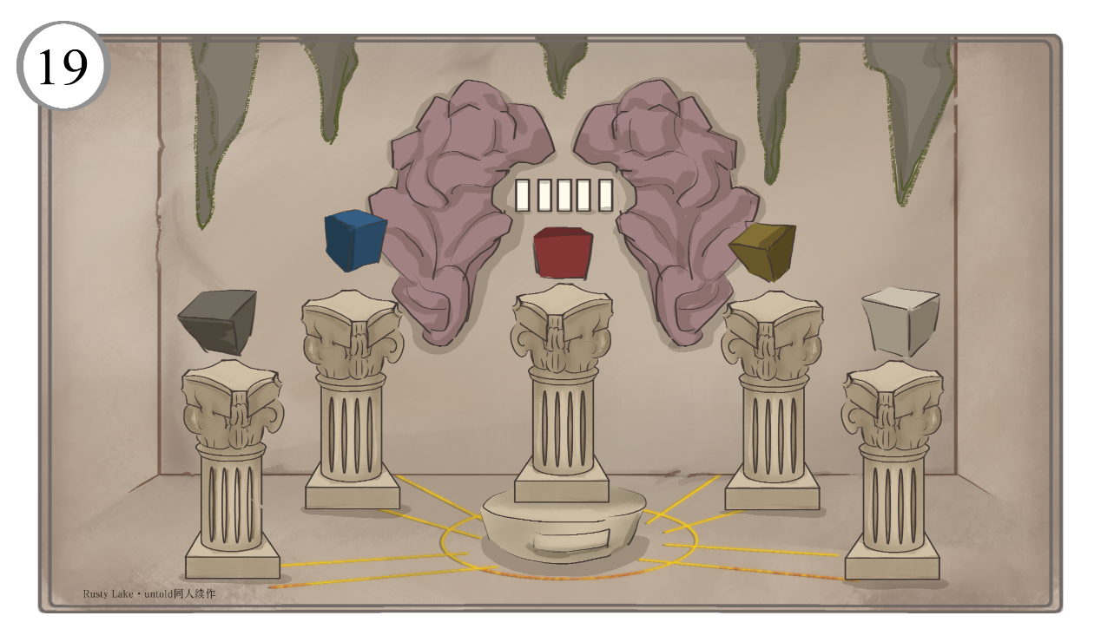

**Thank you for playing.**

*If you have any feedback, suggestions, or questions about the puzzles or story, feel free to reach out to J.P.D.Y.T. The development team also extends heartfelt thanks to everyone who took part in this game.*

***Please support the official Rusty Lake titles.***

***The remaining sections include a plot breakdown and some optional Easter egg content.***



**3.Background**

The protagonist begins the game in what appears to be the **staff lounge of the White Door facility**—indicating that they are likely an **employee of the White Door company**.

However, despite its appearance, the building isn’t quite what it seems. The mascot displayed on the wall is **Mr. Memory** from **BKM (Best Kept Memory)**, not the White Door. This suggests that the facility is **not the real White Door**, but rather a **reconstruction**—a replica built in its likeness. This would explain why the player cannot exit the building and is confined to just one floor and a basement, with no other people in sight.

So, why feature Mr. Memory so prominently? Aside from visual appeal, it’s a symbolic hint: **a connection between the White Door and BKM**.

We know from Rusty Lake lore that the White Door, founded by **Mr. Owl**, is a company conducting memory extraction experiments on psychiatric patients. In its secret ending, **Robert Hill’s white cube develops golden patterns**, which places its timeline **before the creation of golden cubes in the Cave**—making the White Door the **origin of gold cube synthesis**.

This fan game adopts that theory.

As for **BKM**, while no central Rusty Lake characters have appeared there yet, it shares deep ties with **Rose’s lab** (both appearing in the *Metro Blossom* Easter egg) and makes use of similar memory extraction technology. It’s likely not a coincidence.

A strong theory is that **Rose is a key figure at BKM**, and both BKM and the White Door operate under the **oversight of the Rusty Lake trio**—Mr. Owl, Mr. Crow, and Harvey.

This fan game adopts that premise.

But that raises a question: if the Rusty Lake trio already runs the White Door, **why establish BKM**? One simple answer might be profit or a new experimental direction—but this game proposes a deeper symbolic meaning.

**Plot Breakdown**

**1. Story Design**

This fan-made tabletop game is titled **Rusty Lake Untold – The White Door**, clearly inspired by the *Rusty Lake Untold* tabletop series released by Rusty Lake in 2024, often translated in Chinese as *Rusty Lake: The Unspoken Book*. As of the game’s completion date (March 19, 2025), only **Chapter 1** of *Rusty Lake Untold* had been released, and its events and background remain vague.

Specifically, Chapter 1 follows the perspective of an **experiment subject under Rose Vanderboom**. The subject is trapped in a paradoxical loop—waking up in a room, solving puzzles, losing consciousness after having a cube extracted, and waking up again.

The true identity of the player character remains unknown: are they just another test subject? Or are they actually **Rose** or **Albert** in disguise? We also don’t know whether Rose’s experiment connects to the plans of the **Rusty Lake trio**—Mr. Owl, Mr. Crow, and Harvey—or how it ties into the **White Door clinic** or the mysterious company **Best Kept Memory (BKM)**, first hinted at in the 2023 *Underground Blossom* Easter egg.

The meaning behind this experiment—its role in cube creation, the Samsara ascension, and the use of the **Elixir**—remains unclear. In short, the narrative so far feels abrupt and enigmatic.

That’s why, instead of building directly on Chapter 1, this fan game chooses to develop its story by drawing from earlier titles in the Rusty Lake universe. This approach avoids interfering with the studio’s ongoing plans, respects the established lore, and allows players to fully engage without suffering too grim a fate—offering a satisfying emotional experience.

So then… **what story does this fan-made game actually tell?**

**2.Story Summary**

The main character awakens in the **staff room**. After solving a **Fibonacci-based puzzle**, they unlock the door and step into the hallway. From there, they tackle a series of puzzles in the **cafeteria**, **delivery room**, **entertainment room**, and **pharmacy**. Finally, they descend via elevator into the **basement**, where they complete the final puzzle.



It draws inspiration from Western alchemical tradition, where the creation of the **Philosopher’s Stone** involves four key stages: **blackening, whitening, yellowing, and reddening**. The first three stages of alchemy—**blackening**, **whitening**, and **yellowing**—already have corresponding cube colors in the Rusty Lake universe. However, until now, the **red cube**—the final stage of **reddening**—has not yet appeared.

This fan game assumes that **BKM’s mission is to complete the reddening stage**. Once that’s achieved, the Rusty Lake trio can obtain the true **Philosopher’s Stone**, referred to by **Mr. Owl in the Cave** as the **full elixir**. This full elixir would mark the **Glorious Day of Rusty Lake**, and allow certain characters to ascend to the highest stage of the Samsara—the **Deva**.

As for what the full elixir truly does, what the Glorious Day entails, and the meaning behind the Deva—those mysteries remain beyond the scope of this fan game.

**4. Gameplay Structure**

Now, back to the tabletop game itself. In this story, the player takes on the role of an employee working at the White Door. For reasons unknown, they’ve been selected by the Rusty Lake trio, rendered unconscious, and brought to this building—a place that closely resembles the White Door—for a series of puzzles and trials.

Originally, the staff room was not part of the design. Just like in *Rusty Lake Untold: Chapter One*, the starting room featured four beds, and the protagonist would awaken in the **White Door staff dormitory**. However, after some consideration, the starting location was changed to the **staff room**, with the beds replaced by a **sofa**, which suited the narrative flow and design better.

Once players enter the hallway, they’ll see **four doors**. The doors to the **cafeteria** and **delivery room** are unlocked from the start.

Many of the items on the dining room **menu** were submitted by enthusiastic community members—this was the **only part of the game that incorporated player feedback**.

As for the delivery room, its design was inspired directly by *The White Door*. In the game, dinner delivery is fully automated: no doctors show up. Instead, the door opens, and a food cart rolls in by itself.

Based on that idea, we imagined a system that requires **no human labor**—just place the meal in the delivery pipe, and the system handles the rest. Slightly absurd, perhaps, but perfectly acceptable within the world of Rusty Lake.

And if you’re observant, you might notice something curious: the **five patient names in the delivery room** match those of the **five doctors listed on the official White Door website**.

In the early stages of development, we actually considered including the ARG url from *The White Door* in the game. However, after discussion, we ultimately decided against it.

After solving the delivery room puzzle, players gain access to the entertainment room. Entertainment rooms are a favorite setting in many escape room and mystery games, and since they’re already filled with games, embedding puzzles—or even turning the entire room into a puzzle—is quite natural. The dart puzzle found here is also the simplest in the game.

The **pharmacy**, on the other hand, was inspired by the **third night in The White Door** when Robert Hill is injected with unknown substances. Since Rusty Lake never revealed what those injections actually were, this left plenty of creative room for designing puzzles based on mysterious medications.

As players progress through the puzzles, they will encounter or hear several iconic **Rusty Lake quotes**. In the game’s setting, these are meant to be **messages from the Rusty Lake trio**, guiding the chosen employee. As someone favored by the trio, the protagonist is undergoing a **series of trials** to prove themselves—much like the tests **Mr. Owl gave Dale** in *The Mill*.

And finally, the beam of **white light** and the **star-filled vision** that the protagonist sees at the end strongly mirrors the moment in *Case 23 – Chapter 2*, just before Dale collapses.

After Dale loses consciousness, he is transported outside, then summoned again by **Mr. Owl in a storm**, who locks him inside the church.

So now the question is…

**Where will this protagonist be sent next?**

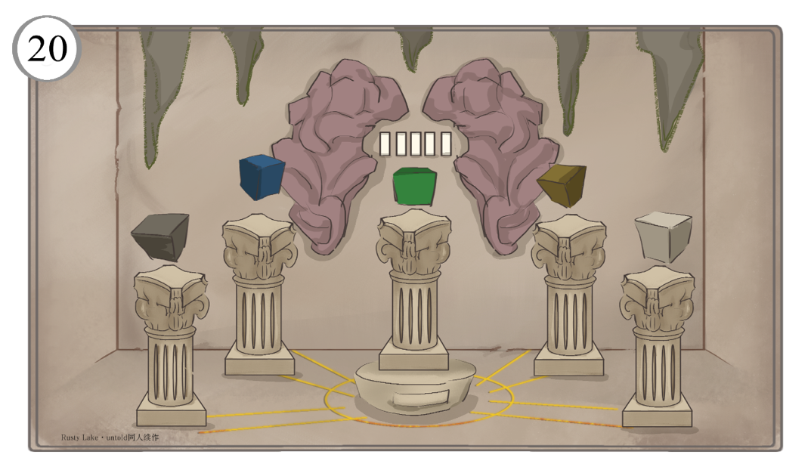

The drawer beneath will unlock once more, revealing a **note with the black-and-white Olympic rings**, along with a **cup of green tea**.

**3. Delivery Room & Cafeteria**

Because the bottom-right ring of the Olympic symbol is green, **deliver the green tea to chute 105**. This causes the **small safe to unlock**, revealing a note that says:

**“letters that can’t be lowercased”**, along with an image of a lockbox.

Head to the dining room and enter the five-letter code: **PEARL**, standing for **PEJING**, **ENGLISH**, **ALBERT**, **RUSTY**, and **LAKE**. Inside the lockbox is a slip of paper with the numbers **2, 3, 5, 8…** — a clear reference to the **Fibonacci sequence**.

**4. Easter Egg Complete**

In the **staff room**, enter **144** into the original lockbox—the only Fibonacci number among the six carpet symbols.

This reveals the **elixir**.

**1. Starting from Pharmacy**

Pick up the cloth to find one side covered in grime. Apply cleaning solution to the dirty side and rinse it with water—this reveals a **flask symbol** and the symbols “♦♣♠”, representing the card numbers **1, 3, and 8** for **Diamonds, Clubs, and Spades** respectively.

Reconnect the plastic tubes in the pharmacy using the sequence **11→x1, 19→x2, 7→x3, 17→x4**. Once connected correctly, the **spherical device will eject a matchbox**.

Open it to find a message inside: **“fire in the hole.”**

**2. Back to the Entertainment Room**

Light a match and place it into the hole in the **bean bag chair**. The chair immediately collapses into itself, leaving behind a **UV flashlight**. The flashlight bears a broken dartboard icon.

Use the UV light to examine **Note #17**, which now reveals the word: **“Hexadecimal↓”**

Following this clue, place the darts into the dart holder from **left to right** in the order of **white, yellow, red, blue, black**.

*This section is not part of the main storyline—it’s a tribute to a segment from the 2025 Rusty Lake Lunar New Year Special. Game Masters may choose freely whether or not to include this part in the tabletop experience.*

**Easter Egg**



Once all four surrounding cubes in the basement have turned colors, pour the elixir onto the **central cube**. Instead of turning red, it turns **green**.

Then the world turns green.

**Easter egg complete.**